**An animated lamp using the Bezier curve tool on cycle render engine.**

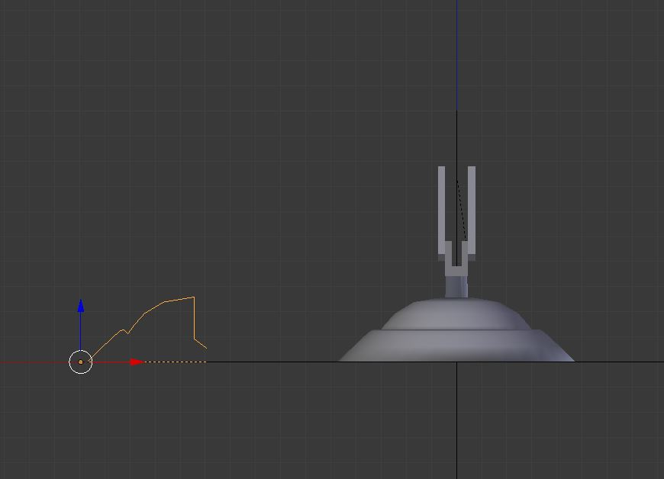

Lamp base using Bezier curve

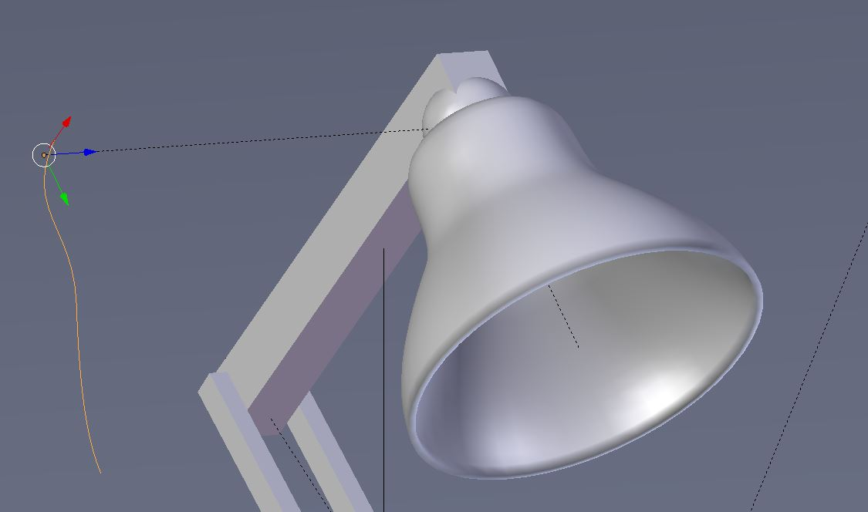

Lamp shade using Bezier curve

**Invisible skeleton on inside the lamp**

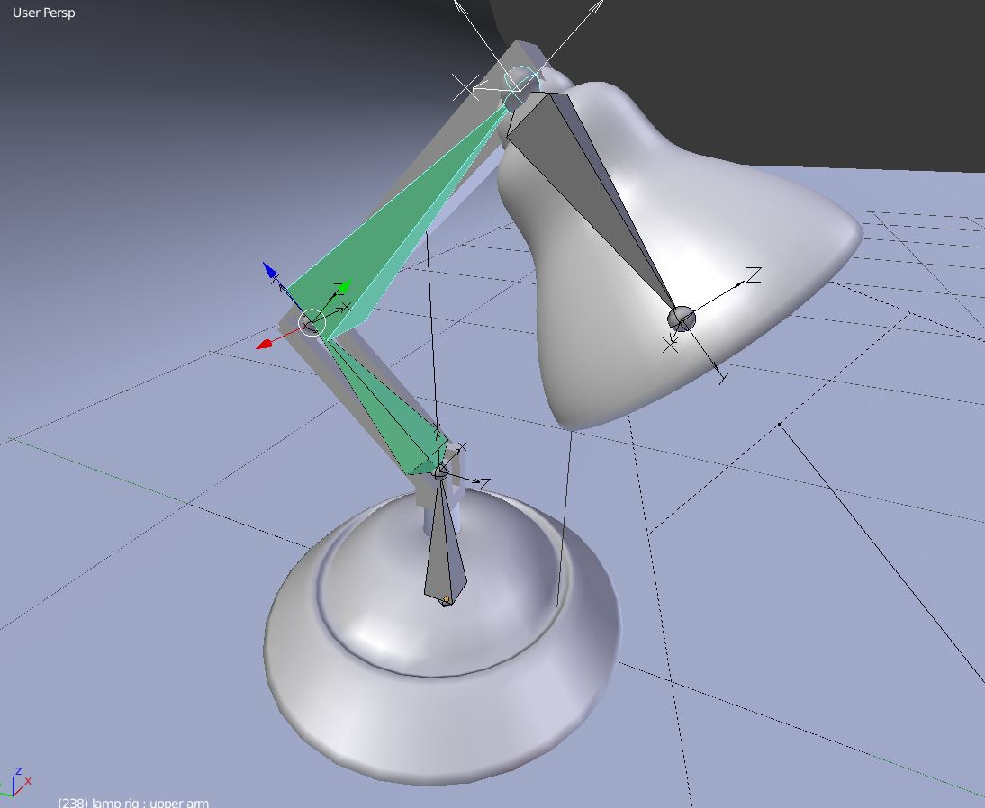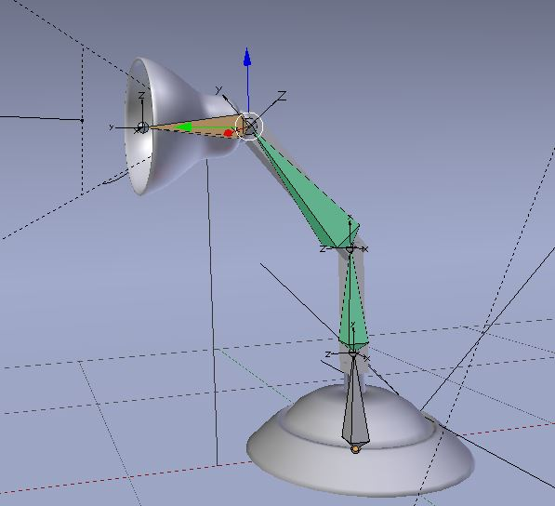

**Final Rendered images**



